PREDICTING THE PRICE OF BITCOIN USING MACHINE LEARNING
CHAPTER 1
INTRODUCTION
Machine learning is about extracting knowledge from data. It is a research field at the intersection of statistics, artificial intelligence, and computer science and is also known as predictive analytics or statistical learning. The application of machine learning methods has in recent years become ubiquitous in everyday life. From automatic recommendations of which movies to watch, to what food to order or which products to buy, to personalized online radio and recognizing your friends in your photos, many modern websites and devices have machine learning algorithms at their core. When you look at a complex website like Facebook, Amazon, or Netflix, it is very likely that every part of the site contains multiple machine learning models. Outside of commercial applications, machine learning has had a tremendous influence on the way data-driven research is done today. The tools introduced in this book have been applied to diverse scientific problems such as understanding stars, finding distant planets, discovering new particles, analysing DNA sequences, and providing personalized cancer treatments. Your application doesn’t need to be as large-scale or world-changing as these examples in order to benefit from machine learning, though. In this chapter, we will explain why machine learning has become so popular and discuss what kinds of problems can be solved using machine learning. Then, we will show you how to build your first machine learning model, introducing important concepts along the way
• Why Machine Learning
In the early days of “intelligent” applications, many systems used hand coded rules of “if “and “else” decisions to process data or adjust to user input. Think of a spam filter whose job is to move the appropriate incoming email messages to a spam folder. You could make up a blacklist of words that would result in an email being marked as spam. This would be an example of using an expert-designed rule system to design an “intelligent” application. Manually crafting decision rules is feasible for some applications, particularly those in which humans have a good understanding of the process to model. However, using hand coded rules to make decisions has two major disadvantages: • The logic required to make a decision is specific to a single domain and task. Changing the task even slightly might require a rewrite of the whole system. • Designing rules requires a deep understanding of how a decision should be made by a human expert. One example of where this hand coded approach will fail is in detecting faces in images. Today, every smart phone can detect a face in an image. However, face detection was an unsolved problem until as recently as 2001. The main problem is that the way in which pixels (which make up an image in a computer) are “perceived” by the computer is very different from how humans perceive a face. This difference in representation makes it basically impossible for a human to come up with a good set of rules to describe what constitutes a face in a digital image. Using machine learning, however, simply presenting a program with a large collection of images of faces is enough for an algorithm to determine what characteristics are needed to identify a face
• Problems Machine Learning Can Solve
The most successful kinds of machine learning algorithms are those that automate decisionmaking processes by generalizing from known examples. In this setting, which is known as supervised learning, the user provides the algorithm with pairs of inputs and desired outputs, and the algorithm finds a way to produce the desired out‐ put given an input. In particular, the algorithm is able to create an output for an input it has never seen before without any help from a human. Going back to our example of spam classification, using machine learning, the user provides the algorithm with a large number of emails (which are the input), together with information about whether any of these emails are spam (which is the desired output). Given a new email, the algorithm will then produce a prediction as to whether the new email is spam. Machine learning algorithms that learn from input/output pairs are called supervised learning algorithms because a “teacher” provides supervision to the algorithms in the form of the desired outputs for each example that they learn from. While creating a dataset of inputs and outputs is often a laborious manual process, supervised learning algorithms are well understood and their performance is easy to measure.
If your application can be formulated as a supervised learning problem, and you are able to create a dataset that includes the desired outcome, machine learning will likely be able to solve your problem. Examples of supervised machine learning tasks include: Identifying the zip code from handwritten digits on an envelope Here the input is a scan of the handwriting, and the desired output is the actual digits in the zip code. To create a dataset for building a machine learning model, you need to collect many envelopes. Then you can read the zip codes yourself and store the digits as your desired outcomes. Determining whether a tumor is benign based on a medical image Here the input is the image, and the output is whether the tumor is benign. To create a dataset for building a model, you need a database of medical images. You also need an expert opinion, so a doctor needs to look at all of the images and decide which tumors are benign and which are not. It might even be necessary to do additional diagnosis beyond the content of the image to determine whether the tumor in the image is cancerous or not. Detecting fraudulent activity in credit card transactions Here the input is a record of the credit card transaction, and the output is whether it is likely to be fraudulent or not. Assuming that you are the entity distributing the credit cards, collecting a dataset means storing all transactions and recording if a user reports any transaction as fraudulent.
An interesting thing to note about these examples is that although the inputs and out puts look fairly straightforward, the data collection process for these three tasks is vastly different. While reading envelopes is laborious, it is easy and cheap. Obtaining medical imaging and diagnoses, on the other hand, requires not only expensive machinery but also rare and expensive expert knowledge, not to mention the ethical concerns and privacy issues. In the example of detecting credit card fraud, data collection is much simpler. Your customers will provide you with the desired output, as they will report fraud. All you have to do to obtain the input/output pairs of fraudulent and non-fraudulent activity is waiting. Unsupervised algorithms are the other type of algorithm that we will cover in this book. In unsupervised learning, only the input data is known, and no known output data is given to the algorithm. While there are many successful applications of these methods, they are usually harder to understand and evaluate.
Examples of unsupervised learning include: Identifying topics in a set of blog posts If you have a large collection of text data, you might want to summarize it and find prevalent themes in it. You might not know beforehand what these topics are, or how many topics there might be. Therefore, there are no known outputs segmenting customers into groups with similar preferences given a set of customer records, you might want to identify which customers are similar, and whether there are groups of customers with similar preferences.
For a shopping site, these might be “parents,” “bookworms,” or “gamers.” Because you don’t know in advance what these groups might be, or even how many there are, you have no known outputs. Detecting abnormal access patterns to a website To identify abuse or bugs, it is often helpful to find access patterns that are differ‐ ent from the norm. Each abnormal pattern might be very different, and you might not have any recorded instances of abnormal behavior. Because in this example you only observe traffic, and you don’t know what constitutes normal and abnormal behavior, this is an unsupervised problem. For both supervised and unsupervised learning tasks, it is important to have a representation of your input data that a computer can understand. Often it is helpful to think of your data as a table.
Each data point that you want to reason about (each email, each customer, each transaction) is a row, and each property that describes that data point (say, the age of a customer or the amount or location of a transaction) is a column. You might describe users by their age, their gender, when they created an account, and how often they have bought from your online shop. You might describe the image of a tumor by the grayscale values of each pixel, or maybe by using the size, shape, and colour of the tumor. Each entity or row here is known as a sample (or data point) in machine learning, while the columns—the properties that describe these entities—are called features.
Later in this book we will go into more detail on the topic of building a good representation of your data, which is called feature extraction or feature engineering. You should keep in mind, however, that no machine learning algorithm will be able to make a prediction on data for which it has no information. For example, if the only feature that you have for a patient is their last name, no algorithm will be able to predict their gender. This information is simply not contained in your data. If you add another feature that contains the patient’s first name, you will have much better luck, as it is often possible to tell the gender by a person’s first name
• Knowing Your Task and Knowing Your Data
Quite possibly the most important part in the machine learning process is under‐ standing the data you are working with and how it relates to the task you want to solve. It will not be effective to randomly choose an algorithm and throw your data at it. It is necessary to understand what is going on in your dataset before you begin building a model. Each algorithm is different in terms of what kind of data and what problem setting it works best for. While you are building a machine learning solution, you should answer, or at least keep in mind, the following questions: ➢ What question(s) am I trying to answer?
➢ Do I think the data collected can answer that question?
➢ What is the best way to phrase my question(s) as a machine learning problem? and Have I collected enough data to represent the problem I want to solve?
➢ What features of the data did I extract, and will these enable the right predictions? ➢ How will I measure success in my application?
➢ How will the machine learning solution interact with other parts of my research or business product?
In a larger context, the algorithms and methods in machine learning are only one part of a greater process to solve a particular problem, and it is good to keep the big picture in mind at all times. Many people spend a lot of time building complex machine learning solutions, only to find out they don’t solve the right problem. When going deep into the technical aspects of machine learning (as we will in this book), it is easy to lose sight of the ultimate goals. While we will not discuss the questions listed here in detail, we still encourage you to keep in mind all the assumptions that you might be making, explicitly or implicitly, when you start building machine learning models.
  - Motivation Bitcoin
offers an efficient means of transferring money over the internet and is controlled by a decentralized network with a transparent set of rules, thus presenting an alternative to central bank-controlled fiat money. There has been a lot of talk about how to price Bitcoin, and we set out here to explore what the cryptocurrency's price might look like in the event it achieves further widespread adoption. However, it is useful to back up a step. Bitcoin and other digital currencies have been touted as alternatives to fiat money. When assessing various research papers on Bitcoin price prediction and the respective methodologies employed in predicting prices of Bitcoin in each research, one would easily notice that even though many research works accurately predicted Bitcoin prices, some others didn’t from the papers on some research works that didn’t accurately predict Bitcoin prices, it can be noticed and argued that higher time complexities are associated with inaccurate predictions; i.e., the algorithms that were used in the research works didn’t manage time to a great extent. Time complexity can be reduced—or time management can be enhanced to a great extent.
  - Problem Definition
Crypto currencies, such as Bit coin, are one of the most controversial and complex technological innovations in today's financial system. This study aims to forecast the movements of Bit coin prices at a high degree of accuracy. To this aim, four different Machine Learning (ML) algorithms are applied, namely, the Support Vector Machines (SVM), the Artificial Neural Network (ANN), the Naï ve Bayes (NB) and the Random Forest (RF) besides the logistic regression (LR) as a benchmark model. In order to test these algorithms, besides existing continuous dataset, discrete dataset was also created and used. For the evaluations of algorithm performances, the F statistic, accuracy statistic, the Mean Absolute Error (MAE), the Root Mean Square Error (RMSE) and the Root Absolute Error (RAE) metrics were used. The t test was used to compare the performances of the SVM, ANN, NB and RF with the performance of the LR. Empirical findings reveal that, while the RF has the highest forecasting performance in the continuous dataset, the NB has the lowest
  - Objective of the Project
Cryptocurrencies, such as Bitcoin, are one of the most controversial and complex technological innovations in today's financial system. This study aims to forecast the movements of Bitcoin prices at a high degree of accuracy. To this aim, four different Machine Learning (ML) algorithms are applied, namely, the Support Vector Machines (SVM), the Artificial Neural Network (ANN), the Naï ve Bayes (NB) and the Random Forest (RF) besides the logistic regression (LR) as a benchmark model. In order to test these algorithms, besides existing continuous dataset, discrete dataset was also created and used. For the evaluations of algorithm performances, the F statistic, accuracy statistic, the Mean Absolute Error (MAE), the Root Mean Square Error (RMSE) and the Root Absolute Error (RAE) metrics were used.
The t test was used to compare the performances of the SVM, ANN, NB and RF with the performance of the LR. Empirical findings reveal that, while the RF has the highest forecasting performance in the continuous dataset, the NB has the lowest. On the other hand, while the ANN has the highest and the NB the lowest performance in the discrete dataset. Furthermore, the discrete dataset improves the overall forecasting performance in all algorithms (models) estimated.
  - Limitations of the Project
Bitcoins are still only accepted by a very small group of online merchants. This makes it unfeasible to completely rely on Bitcoins as a currency. There is also a possibility that governments might force merchants to not use Bitcoins to ensure that users’ transactions can be tracked. The Bitcoin system could contain unexploited flaws. As this is a fairly new system, if Bitcoins were adopted widely, and a flaw was found, it could give tremendous wealth to the exploiter at the expense of destroying the Bitcoin economy. Since Bitcoins do not have a physical form, it cannot be used in physical stores.
It would always have to be converted to other currencies. Cards with Bitcoin wallet information stored in them have been proposed, but there is no consensus on a particular system. Since there would be multiple competing systems, merchants would find it unfeasible to support all Bitcoin cards, and therefore users would be forced to convert Bitcoins anyway, unless a universal system is proposed and implemented. If there is no proper dataset then it can’t be implemented accurately These are the few limitations of the project.
  - Organization of report
The first chapter deals with the introduction of the bitcoin price prediction, motivation for developing this project, problem definition, objective of the project. The second chapter deals with the system specifications required for developing the project. It includes hardware and software specifications. The third chapter gives you the preview about literature survey which includes the information about existing system, disadvantages of existing system and proposed system. The fourth chapter is for analysis of the project which includes data and requirement analysis, module organization. The fifth chapter deals with the design of the project which includes data flow diagrams. The sixth chapter deals with the implementation of the project which includes module definition and result analysis of the project. The seventh chapter tells about the testing and validations. Finally eighth chapter deals with the conclusion and future enhancement.
CHAPTER 2
LITERATURE SURVEY
2.1 Existing System
Linear regression model in linear regression is a linear approach to modelling the relationship between a dependent variable and independent variables. The case of linear variable is called simple linear regression [8]. In this paper I am using the linear regression model for relationship between a dependent variable and one or more independent variables.
K-Nearest Neighbour K-means creates k groups from a set of objects so that the members of a group are more similar and based on this data is clustered as normal, stressed or highly stressed. [1] We can compute the distance between two dependent and independent variables using some distance function d (x, y), where x, y are scenarios composed Number of features, such that x={x1,…,xN}, y={y1,…,yN}. Break the principal third of the information e the comparing loads of highlights discovered utilizing the Bayesian relapse strategy.
The relapse fills in as pursues. At time t, assess three vectors of past costs of various time interims (180s, 360s and 720s). For each time interim, ascertain the comparability between these vectors and our 20 best kmeans designs with their realized value hop, to locate the probabilistic value change dp. Compute the loads, for each component utilizing a Differential Advancement enhancement work. [3]. The third arrangement of costs is utilized to assess the calculation, by running the equivalent Bayesian relapse to assess highlights, and consolidating those with the loads determined in stage 2 C. Naïve Bayes Naïve Bayes techniques are a great deal of coordinated learning figurings reliant on applying Bayes' speculation with the "honest" supposition of opportunity between each pair of features [2]. Overlooking their plainly overimproved suppositions, guiltless Bayes classifiers have worked very well in some genuine conditions. They require a limited measure of preparing information to survey the critical parameters.
Honest Bayes understudies and classifiers can be unbelievably speedy appeared differently in relation to progressively present-day systems. The decoupling of the class prohibitive component dispersals suggests that each movement can be uninhibitedly evaluated as a onedimensional scattering. This along these lines decreases issues originating from the scourge of dimensionality. We used the execution gave by Scikit-make s ense of how to this.
Disadvantages of Exstiting System
Using regression to make predictions doesn’t necessarily involve predicting the future. Instead, you predict the mean of the dependent variable given specific values of the independent variable(s). For our example, we’ll use one independent variable to predict the dependent variable. Psychic predictions are things that just pop into mind and are not often verified against reality. Unsurprisingly, predictions in the regression context are more rigorous. We need to collect data for relevant variables, formulate a model, and evaluate how well the model fits .
1) Predicted value is continuous, not probabilistic
In a binary classification problem, what we are interested in is the probability of an occurring. Probability is ranged between 0 and 1, where the probability of something certain to happen is 1, and 0 is something unlikely to happen. But in linear regression, we are predicting an absolute number, which can range outside 0 and 1.
2) Sensitive to imbalance data
As linear regression tries to fit the regression line by minimising prediction error, in order to minimise the distance of predicted and actual value for customers age between 60 to 70. Let’s train a logistic regression model with the same dataset.
2.2 Proposed System
In estimations and AI, rope (least absolute shrinkage selection operator or LASSO) is a lose the faith assessment framework that performs both variable choice and regularization so as to refresh the check exactness and interpretability of the legitimate model it produces. Diverse tie assortments have been made so as to fix certain constraints of the fundamental strategy and to make the system dynamically huge for unequivocal issues. In every practical sense these emphasis on as for or using various sorts of conditions among the co variates. Adaptable net regularization fuses an extra edge lose the faith like order which improves execution when the measure of markers is more noteworthy than the model size, enables the technique to pick ardently related factors together, and improves generally want accuracy Decision Tree This is one of my preferred calculations and I use it oftentimes.
It is a kind of directed learning calculation that is for the most part utilized for order issues. Shockingly, it works for both clear cut and consistent ward factors. In this calculation we split the populace into at least two homogeneous sets. This is done dependent on most huge properties/autonomous factors to make as particular gatherings as could reasonably be expected. C. KNN (k- Nearest Neighbours). It very well may be utilized for both order and relapse issues. Be that as it may, it is all the more generally utilized in characterization issues in the business.
K nearest neighbors is a straight forward calculation that stores every single accessible case and arranges new cases by a lion's share vote of its k neighbors. The case being allotted to the class is generally normal among its K closest neighbors estimated by a separation work. These separation capacities can be Euclidean, Manhattan, Minkowski and Hamming separation. Initial three capacities are utilized for constant capacity and fourth one (Hamming) for clear cut factors.
o Advantages of Proposed System
LSTMs provide us with a large range of parameters such as learning rates, and input and output biases. Hence, no need for fine adjustments. The complexity to update each weight is reduced to O(1) with LSTMs, similar to that of Back Propagation Through Time (BPTT), which is an advantage.
- Exploding and Vanishing Gradients:
During the training process of a network, the main goal is to minimize loss (in terms of error or cost) observed in the output when training data is sent through it. We calculate the gradient, that is, loss with respect to a particular set of weights, adjust the weights accordingly and repeat this process until we get an optimal set of weights for which loss is minimum. This is the concept of backtracking. Sometimes, it so happens that the gradient is almost negligible. It must be noted that the gradient of a layer depends on certain components in the successive layers.
- Variations:
With the increasing popularity of LSTMs, various alterations have been tried on the conventional LSTM architecture to simplify the internal design of cells to make them work in a more efficient way and to reduce the computational complexity. LSTM can hold memory for long time so it can predict exact price of future time based on past data
CHAPTER 3
PROJECT DESCRIPTION
Bitcoin is the worlds’ most valuable cryptocurrency and is traded on over 40 exchanges worldwide accepting over 30 different currencies. It has a current market capitalization of 9 billion USD according to https://www.blockchain.info/ and sees over 250,000 transactions taking place per day. As a currency, Bitcoin offers a novel opportunity for price prediction due its relatively young age and resulting volatility, which is far greater than that of fifiat currencies. It is also unique in relation to traditional fifiat currencies in terms of its open nature; no complete data exists regarding cash transactions or money in circulation for fifiat currencies.
Prediction of mature financial markets such as the stock market has been researched at length. Bitcoin presents an interesting parallel to this as it is a time series prediction problem in a market still in its transient stage. Traditional time series prediction methods such as HoltWinters exponential smoothing models rely on linear assumptions and require data that can be broken down into trend, seasonal and noise to be effective. This type of methodology is more suitable for a task such as forecasting sales where seasonal effects are present. Due to the lack of seasonality in the Bitcoin market and its high volatility, these methods are not very effective for this task. Given the complexity of the task, deep learning makes for an interesting technological solution based on its performance in similar areas. The recurrent neural network (RNN) and the long short-term memory (LSTM) are favoured over the traditional multilayer perceptron (MLP) due to the temporal nature of Bitcoin data.
The aim of this paper is to investigate with what accuracy the price of Bitcoin can be predicted using machine learning and compare parallelisation methods executed on multi-core and GPU environments. This paper contributes in the following manner: of approximately 653 papers published on Bitcoin, only 7 (at the time of writing) are related to machine learning for prediction. To facilitate a comparison to more traditional approaches in financial forecasting, an ARIMA time series model is also developed for performance comparison purposes with the neural network models.
The independent variable for this study is the closing price of Bitcoin in USD taken from the CoinDesk Bitcoin Price Index. Rather than focusing on one specific exchange, we take the average price from five major Bitcoin exchanges: Bit stamp, Biaffine, Coinbase, OkCoin and it Bit. If we were to implement trades based on the signals it would be beneficial to focus on just one exchange. To assess the performance of models, we use the root mean squared error (RMSE) of the closing price and further encode the predicted price into categorical variable reflecting: price up, down or no change. This latter step allows for additional performance metrics that would be useful to a trader in the formation of a trading strategy: classification accuracy, specificity, sensitivity and precision. The dependent variables for this paper come from the CoinDesk website, and Blockchain.info. In addition to the closing price, the opening price, daily high and daily low are also included as well as Blockchain data, i.e., the mining difficulty and hash rate. The features which have been engineered (considered as technical analysis indicators include two simple moving averages (SMA) and a de-noised closing price.
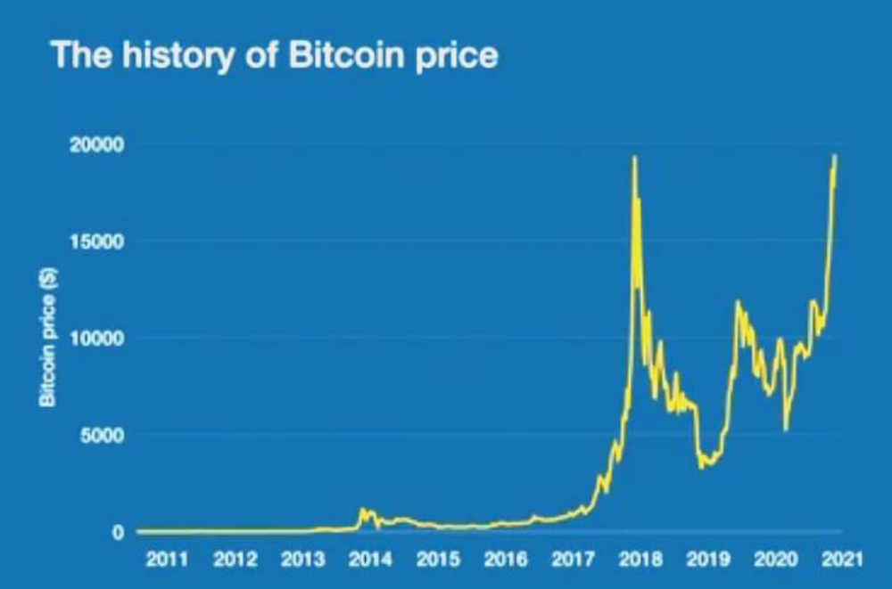
CHAPTER 4
METHODOLGY
Recurrent Neural Network (RNN)
The first parameter to consider was the temporal length window. As suggested by supporting literature these types of networks may struggle to learn long term dependencies using gradient based optimisation. An autocorrelation function (ACF) was run for the closing price time series to assess the relationship between the current closing price and previous or future closing prices. While this is not a guarantee of predictive power for this length, it was a better choice than random choice. Closing price is correlated with a lag of up to 20 days in many cases, with isolated cases at 34, 45 and 47 days. This led the grid search for the temporal window to test from 2 to 20, 34, 45 and 47 days. To ensure a robust search, larger time periods of up to 100 days were also tested in increments of five.
The most effective window temporal length was 24. In addition to the temporal window, some hyperparameters also need tuning: Learning rate is the parameter that guides stochastic gradient descent (SGD), i.e., how the network learns. Similarly, momentum updates the learning rate to avoid the model falling into local minima (in terms of error) and attempts to move towards the global minimum of the error function. We used the RMSprop optimiser to improve on SGD, as it keeps a running average of recent gradients and as a result is more robust against information loss.
According to Heaton, one hidden layer is enough to approximate the vast majority of non-linear functions. Two hidden layers were also explored and were chosen as they achieved lower validation error. Heaton also recommends for the number of hidden nodes to select between the number of input and output nodes. In this case, less than 20 nodes per layer resulted in poor performance. 50 and 100 nodes were tested with good performance. However, too many nodes can increase the chances of overfifitting, and significantly increase the time needed to train the network. As 20 nodes performed sufficiently well this was chosen for the final model.
An activation function, a non-linear stepwise equation that passes signals between layers, is also needed. The options explored were Tanh, ReLu, and Sigmoid. Tanh performed the best but the differences were not significant. The final parameters for selection are batch size and number of training epochs. Batch size was found to have little effect on accuracy but considerable effect on training time when using smaller batches in this case. The number of epochs tested ranged from 10 to 10000, however, too many training epochs can result in overfifitting. To reduce the risk of overfifitting, dropout was implemented as discussed above. Optimal dropout between 0.1 and 1 was searched for both layers with .5 dropout the optimal solution for both layers. A Keras call-back method was also used to stop the training of the model if its performance on validation data did not improve after 5 epochs to prevent overfifitting. Generally, the RNN converged between 20 and 40 epochs with early stopping.
• Long Short-Term Memory (LSTM)
In terms of temporal length, the LSTM is considerably better at learning long term dependencies. As a result, picking a long window was less detrimental for the LSTM. This process followed a similar process to the RNN in which autocorrelation lag was used as a guideline. The LSTM performed poorly on smaller window sizes. Its most effective length found was 100 days, and two hidden LSTM layers were chosen. For a time, series task two layers is enough to find non-linear relationships among the data. 20 hidden nodes were also chosen for both layers as per the RNN model. The Hyper as library2 was used to implement the Bayesian optimisation of the network parameters. The optimiser searched for the optimal model in terms of how much dropout per layer and which optimizer to use. RMSprop again performed the best for this task. In the LSTM model, activation functions weren’t changed as the LSTM has a particular sequence of tanh and sigmoid activation functions for the different gates within the cell.
LSTM models converged between 50 and 100 epochs with early stopping. Similar to the RNN, batch size was found to have a greater effect on execution time than accuracy. This may be due to the relatively small size of the dataset
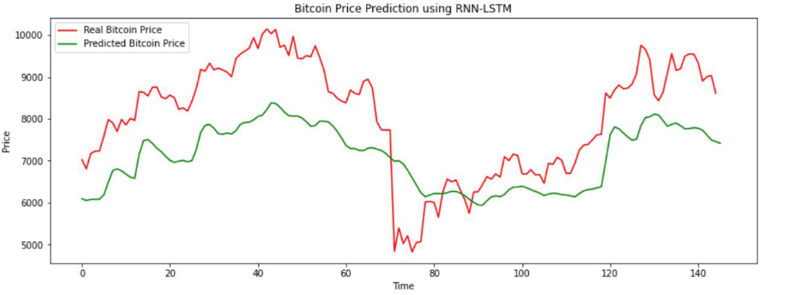 Fig.4.1 Bitcoin Price Using RNN-LSTM

CHAPTER 5
ANALYSIS
2.3 Module Organization
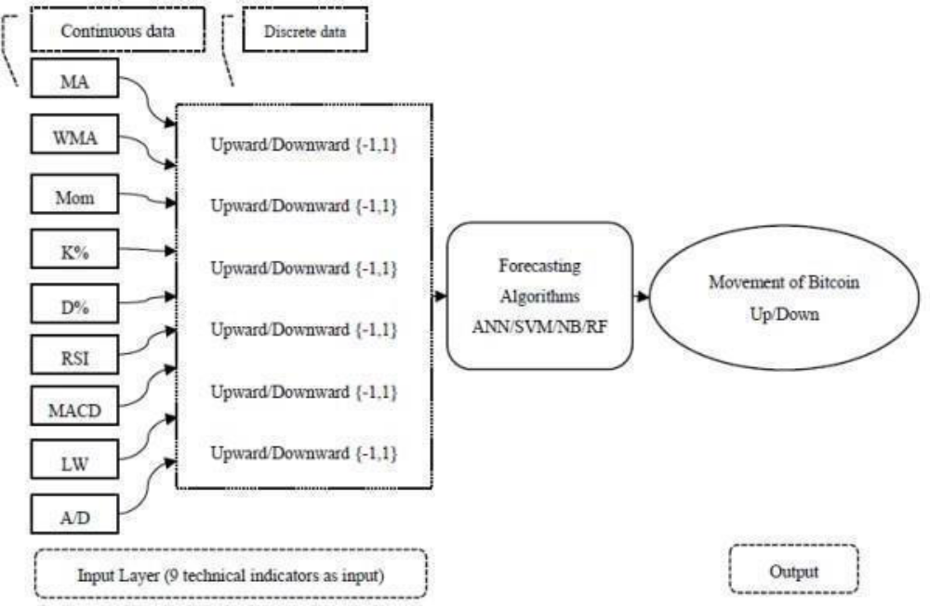

The rapid development of digital currencies during the last decade is one of the most controversial and ambiguous innovations in the modern global economy. Rising technology changes the structure of economies, financial markets and payment methods. The world's financial markets have become more digital than ever before and cashless society is around the corner. Today's technology enables people to create their own money (digital cryptocurrency) and the functions of the central banks, as lenders of last resorts, are discussed and questioned. Bit coin, as a financial phenomenon, as well as other crypto currencies, are in fact data treated like money. Users (called "miners") send and receive these crypto currencies (data) electronically from their computers in peer-to-peer network systems to pay for things, if other parties are willing to accept such payments. Market capitalization and the number of miners of 2957 crypto currencies reached ＄221 billion (Bit coin ＄147) and 42 million in 2019. The price of Bitcoin has drastically increased from ＄0.0008 to ＄10,168 per single coin from being launched in January 2009 to February 2020. Hence, first and foremost, the Bit coin and other crypto currencies have become extremely popular due to increasing number of their users and their huge gains. On the other hand, Bit coin's and other crypto currencies' prices-series, similar to other financial assets-series, exhibit chaotic fluctuations. Because of asymmetric information problems in financial markets, increasing economic-political uncertainties and changing behaviors of miners may make the prices of crypto currencies not easily predictable for investors. Crypto currencies' forecasting difficulties may well be higher than those of other conventional assets; although they are so popular for investors, very little is known about them, about how they work and how they are created (mined), since they are not physical currencies. Accordingly, accurately forecasting their prices may minimize potential losses-risks for users.
2.4 Feasibility Study
Many studies empirically compare traditional models and ML algorithms concerning their forecasting performances. In some studies, traditional models outperform ML algorithms, while in others the latter outperform the former. For instance, compare the Bayesian neural network and traditional models in forecasting Bit coin prices. They find that the Bayesian neural network offers higher performance than traditional models. Similarly, compare the accuracy rates of ML algorithms with auto regressive integrated moving average (ARIMA) model for forecasting Bit coin prices. They find that ML outperforms the ARIMA model. Find that the recurrent neural network (RNN) outperforms the ARIMA model in forecasting the prices of cryptocurrencies. apply the ARIMA model and ML algorithms to forecast Bitcoin prices and find that ML algorithms outperform the ARIMA model. examine the impacts of news articles on Bitcoin prices and find that ML algorithms offer better performance than traditional models.
However, compare the performances of the ARIMA with the RF and the SVM when forecasting Bitcoin prices. They find that the ARIMA model outperforms ML algorithms. compare traditional models, such as logistic regression and discriminant analysis, with ML algorithms and find that traditional models show better performance in forecasting Bitcoin prices.
On the other hand, in some studies, different ML algorithms are compared against each other for their forecasting performances. For instance, compare the deep neural network (DNN) and long short-term memory (LSTM) for forecasting Bitcoin prices and find that the LSTM slightly outperforms the DNN compare the LSTM and gradient boosting algorithms and find that the LSTM provides a better performance than the gradient boosting algorithm. Furthermore, use the nonparametric regression method of smoothing splines on 1- minute Bitcoin price data. Neural networks provide better performance than various competing models on the prediction of Bitcoin returns. use adaptive multilevel time series detection methodology to predict the bubbles in Bitcoin. They find that this methodology is robust to be used not only on cryptocurrencies but also in financial markets. use non-parametric causality-in-quantiles tes to investigate casual relation between trading volume and Bitcoin returns and volatility. They reveal the importance of modelling nonlinearity and accounting on causal relationships. uses the GARCH models to evaluate the volatility of Bitcoin returns. The author finds that tGARCH-NIG has the best performance in prediction of the volatilities. use the least absolute shrinkage and selection operator (LASSO) framework to examine the effects of factors on Bitcoin returns. The find that gold returns have the most important effects on returns

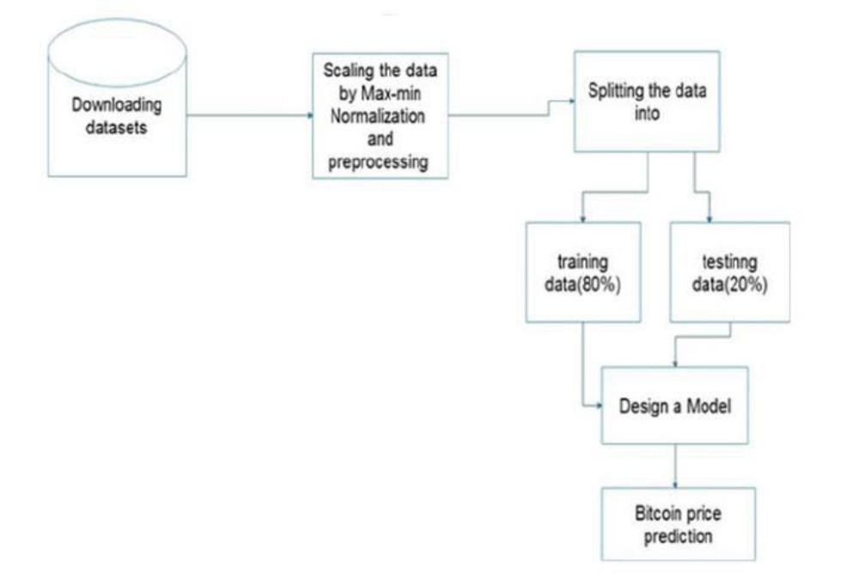 Fig.5.2 Dataflow Diagram

CHAPTER 6
SYSTEM SPECIFICATIONS
• S/W SPECIFICATIONS:
o Operating system :
Windows 10 (any windows operating system)
. o Coding Language :
Python.
o Front-End :
Python
o IDE :
Anaconda IDE – Jupyter Note Book
o System :
• H/W SPECIFICATIONS:
o System :
Intel i3 2.4 GHz.
o Hard Disk :
100 GB above.
o Monitor :
14 Colour Monitor or any size.
o Mouse :
Optical Mouse. o Ram : 2 GB

6.1 Installing Anaconda on Windows
This tutorial will demonstrate how you can install Anaconda, a powerful package manager, on Microsoft Windows.
Anaconda is a package manager, an environment manager, and Python distribution that contains a collection of many opensource packages. This is advantageous as when you are working on a data science project, you will find that you need many different packages (NumPy, scikit-learn, SciPy, pandas to name a few), which an installation of Anaconda comes preinstalled with. If you need additional packages after installing Anaconda, you can use Anaconda's package manager, conda, or pip to install those packages. This is highly advantageous as you don't have to manage dependencies between multiple packages yourself. Conda even makes it easy to switch between Python 2 and 3.
Download and Install Anaconda
Go to the Anaconda website and choose a Python 3.x graphical installer (A) or a Python 2.x graphical installer (B).
If you aren't sure which Python versi on you want to install, choose Python.
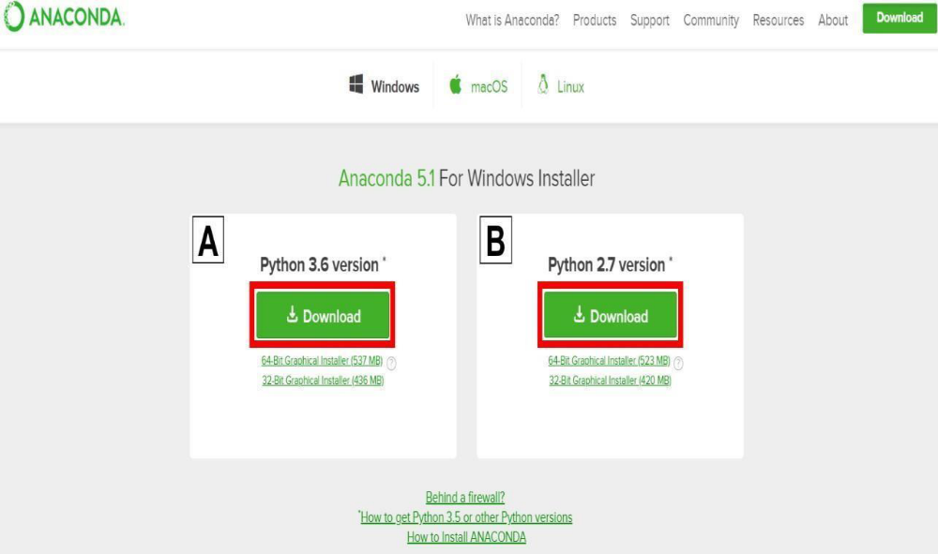
Fig.6.1 Installation window
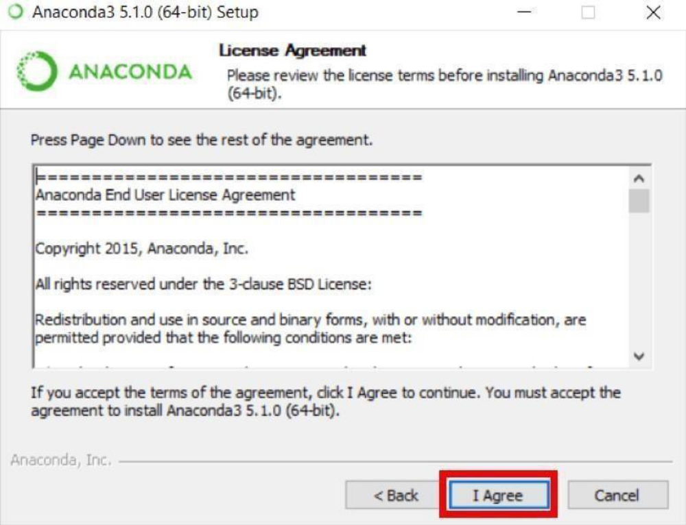
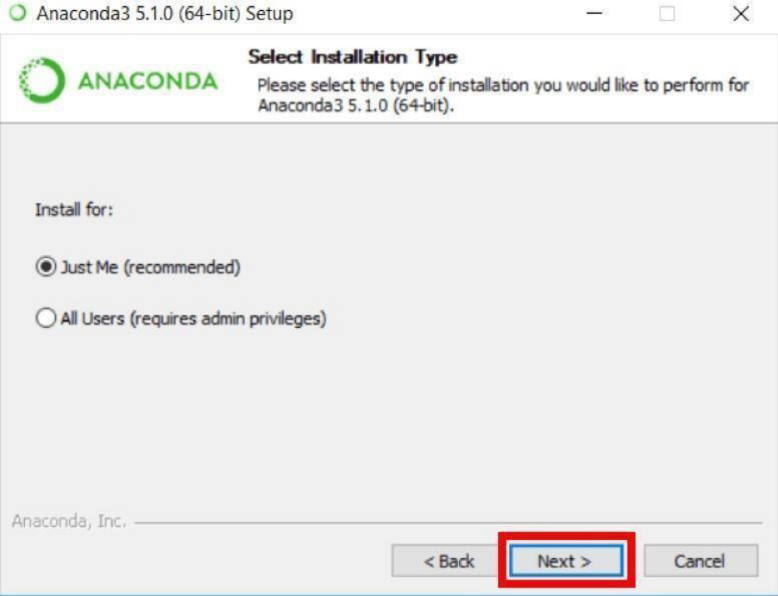
Fig.6.3 User Installation window

This is an important part of the installation process. The recommended approach is to not check This is an important part of the installation process. The recommended approach is to not check This is an important part of the installation process. The recommended approach is to not check This is an important part of the installation process. The recommended approach is to not check This is an important part of the installation process. The recommended approach is to not check This is an important part of the installation process. The recommended approach is to not check This is an important part of the installation process. The recommended approach is to not check This is an important part of the installation process. The recommended approach is to not check
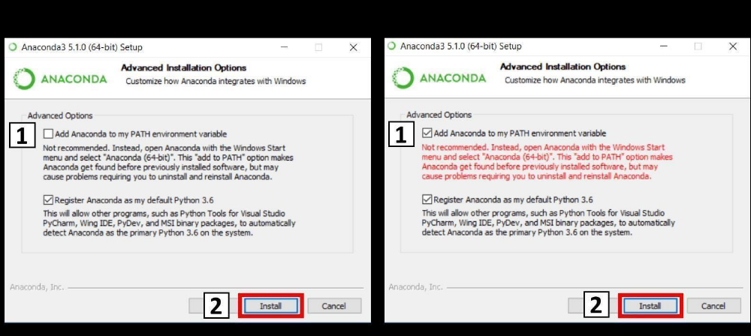
Fig.6.4 Installation Path Window

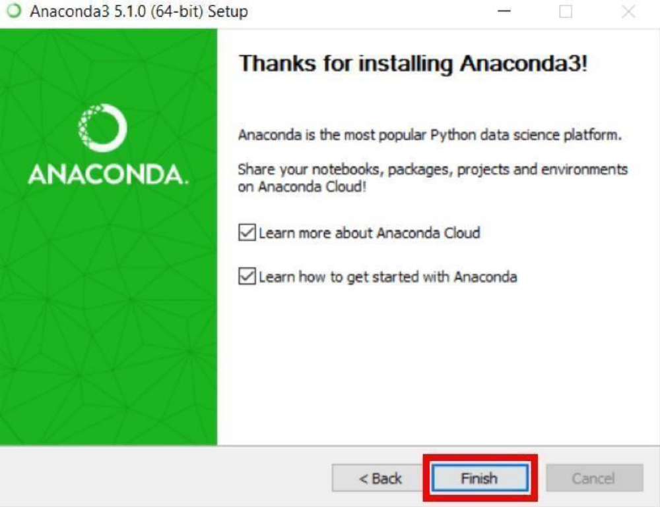
Fig.6.5 Final Installation Window

6.2 Add Anaconda to Path
This is an optional step. This is for the case where you didn't check the box in step 6 and now want to add Anaconda to your Path. The advantage of this is that you will be able to use Anaconda in your Command Prompt, Git Bash, cmder etc.
- Open a Command Prompt. 2. Check if you already have Anaconda added to your path. Enter the commands below into your Command Prompt. This is checking if you already have Anaconda added to your path. If you get a command not recognized error like in the left side of the image below, proceed to step 3. If you get an output similar to the right side of the image below, you have already added
- Anaconda to your path. conda –version
3. If you don't know where your conda and/or python is, open an Anaconda Prompt and type in the following commands. This is telling you where conda and python are located on your computer.
4. Add conda and python to your PATH. You can do this by going to your Environment Variables and adding the output of step 3 (enclosed in the red rectangle) to your path. If you are having issues, on adding conda and python to your PATH.
5. Open a new Command Prompt. Try typing conda --version and python --version into the Command Prompt to check to see if everything went well.
• Anaconda Conclusion
This tutorial provided a quick guide on how to install Anaconda on Windows as well as how to deal with a common installation issue.
• What is Jupyter notebook?
If you are a student, you must be using a class notebook to take various class notes, or if you are a business professional, you might be using a writing pad to pen down important notes, either for your purpose or to present to someone else. The typical content that goes in a student's notebook can be text in various formats such as bold and italic, or a table, a mathematical equation, or creative stuff like hand-drawn images and so on. Not to forget that if it's a programmer's notebook, it will also contain a lot of programming code. Now, you want to continue with this practice of writing all such stuff in a single place online. Jupyter notebook comes to the rescue here. It is a web-based platform that allows you to write narrative text in various formats, include a table or an image, write equations and code in Various programming languages, all in one place. Apart from this, Jupyter notebook also allows you to write LaTeX code, include HTML code and embed a YouTube video.
The Jupyter Notebook is an open-source web application that allows you to create and share documents that contain live code, equations, visualizations and narrative text. Uses include data cleaning and transformation, numerical simulation, statistical modelling, data visualization, machine learning, and much more. A backdrop: The Jupyter Notebook is one of two facets of the Jupyter project which started to develop open-source, open-standards for interactive computing across dozens of programming languages. Another being JupyterLab which is the advanced version of Jupyter Notebook interface.
• How to install Jupyter environment?
If the above command fails, you can continue reading this section. Otherwise, you can safely skip this and proceed to the next section. In case the command fails and you get the error similar (not exact) to the one shown below, continue with this section to understand the installation process.

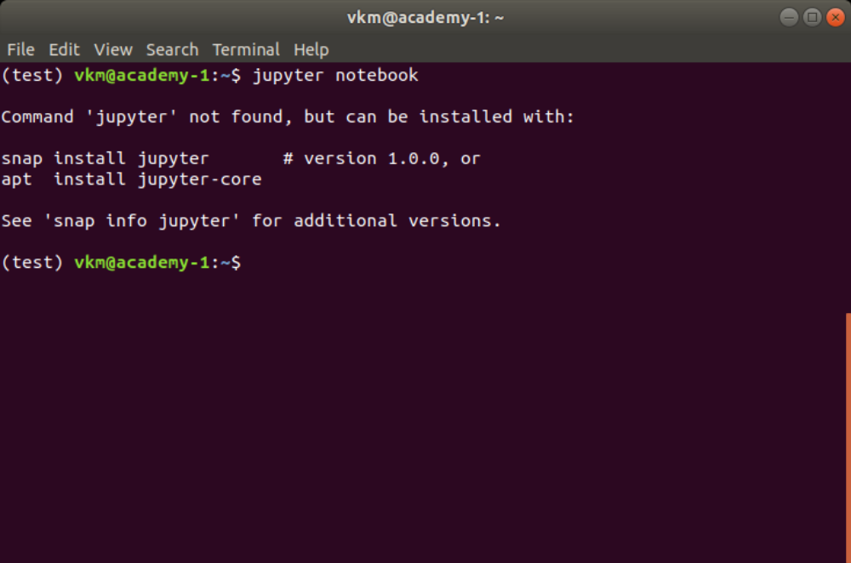
Fig 6.6 Jupyter Window
Two popular methods using which Python can be installed on your workstation. They are
1. Installing Python using Anaconda Distribution
2. Installing Raw Python
While Jupyter runs code in many programming languages, Python is a requirement for installing the Jupyter Notebook
6.3 Installing Jupyter Notebook using Anaconda
If you have installed Python using Anaconda Distribution, you are good to go. Anaconda Distribution includes Python, the Jupyter Notebook, and other commonly used packages for the scientific community.
If you don't have any version of Python installed, the recommended way to install Python is using Anaconda Distribution. It should be pretty simple to get Python installed.
First, download the latest version of Anaconda Distribution.
Second, install the downloaded version of Anaconda.
You have installed Jupyter Notebook. To check whether the installation is successful or not, and run the Jupyter Notebook, run the following command in the Anaconda prompt or command prompt (Windows) or terminal (Mac/Linux). If you get an error upon running the above command (which should not happen), try the following method.

• Installing Jupyter Notebook using pip
When you install Python directly from its official website it does not include Jupyter Notebook in its standard library. In this case, you need to install Jupyter Notebook using the pip. The process is as follows:
1. Open a new command prompt (Windows) or terminal (Mac/Linux)
2. Execute the following command to install Jupyter Notebook
python -m pip install Jupyter
or if you are using Python3
python3 -m pip install jupyter
or simply
pip install jupyter
• How to run or open Jupyter Notebooks?
After you have installed the Jupyter Notebook on your computer, you are ready to run the notebook server. If you are reading this article from the beginning, then you might already know how to run Jupyter Notebook. However, if you have skipped the previous sections and directly jumped here, the below mentioned steps shows how to run the Jupyter Notebook Upon executing the above command, the terminal or command prompt will print some information about the Jupyter Notebooks being loaded. It might look something like as shown in the below snapshot. Be mindful that the information printed would be different for each workstation.
Keep the terminal open as it is. It will then open the default web browser with the URL mentioned in the command prompt or terminal. When the notebook opens in your browser, you
will see the Notebook Homepage as shown in the below snapshot. This will list the notebook files and subdirectories in the directory where the notebook server was started.
In case you are using Anaconda distribution for Python, you can open Anaconda Navigator (using the Start Menu (Windows), Applications folder (Mac), or Softwares folder (Linux)) shown below which allows you to open Jupyter Notebook using point and click. Once the Navigator application is open, you can click on the Launch button within the Notebook dialogue to launch the Jupyter Notebook application. Upon clicking the Launch button, you will be presented by the homepage that we'd seen earlier.
Now, let's understand how Jupyter environment works, I won't be going technical, though. As the Jupyter Notebook is a web application, it works on a server-client architecture. When you execute the command jupyter notebook, the Jupyter software starts the server locally in the console where the command is executed, and the Jupyter Notebook homepage that opens in the web browser works as the client. Whatever you perform, that is, create or upload a new notebook, or save the existing one, the client notebook on which you are working, will keep communicating with the server running in the console/command line.
To keep notebooks running smoothly, we need to keep the command prompt or terminal open, even after it has opened homepage. If you close it, notebooks that you are working with, won't be able to communicate with the local server, and hence, any work you do, will not be saved on persistent memory.
The next step is to learn various components of Jupyter software.
• What are the different components of Jupyter notebooks?
I assume that you are following the chronological order of this article. If so, then you have learned what Jupyter notebooks are, how to install it, and how to run and open it. If not, then I would recommend you to go through them to get an overall picture. Nevertheless, if you are already familiar with those parts, go on and keep learning.
In this section, I will explain the various components of Jupyter software. When you start Jupyter Notebook application, and you'll be presented with the homepage. Let's start exploring it. Below shown is the snapshot of the homepage that you'd seen earlier, but with numbers assigned to each component to make our learning easier.
Here's the description of each numbered point shown in the snapshot.
1. It is the URL on which Jupyter server is running. If you are running the Jupyter on localhost, this would be the same URL shown in the console when you started Jupyter software.
2. The Files tab lists the directories and files in the home folder, which usually is the home directory of the user logged in to the computer.
3. The Running tab shows you a list of all open notebooks. When you start a new notebook or open an existing notebook, a kernel will get attached to it. All such running kernels will be listed under this tab.
4. If you want to open an existing Jupyter notebook (that ends with. ipynb extension), it needs to be listed in the Files tab. If it is not listed, you need to upload it using he Upload button which will open a file browser for you to load the file.
5. Quit and Logout buttons allow you to logout and shutdown the server. When you quit, all the opened notebooks will be closed, and the server will get shutdown.
6. The New button allows you to create a new notebook, text file, folder, or terminal. The snapshot shown below shows that you can create a notebook in Python, Julia, and R language. The notebook that you create will be associated with a respective kernel. When you install Jupyter environment as shown in the previous section, it is very likely that you will have only one option for the kernel, that is, Python. In order to add new languages, you can refer to this link.
You can create a new notebook by clicking on the respective language name. Regardless of what language you choose, the new notebook that you create will have the same appearance. The difference would be in terms of the kernel attached to it. If I click on Python 3 on the dropdown opened, a new notebook with Python kernel attached to it will be created. The empty Jupyter notebook is shown in the snapshot below. (Obviously without numbers).
The newly created notebook has various components which are explained below:
1. The title is the name of the notebook. The title you set becomes the file name for the notebook, and it will have the extension as. ipynb which stands for IPython NoteBook.
2. The checkpoint shows you the time when your notebook was saved last.
3. The menu bar lists various menus that allow you to download the notebook (in multiple formats), open a new notebook, edit the notebook, customise the headers, manipulate cells, nudge the kernel, access help and so on.
4. The shortcut bar lists commonly used shortcuts such as save to save the notebook, add a cell, cut, copy to manipulate cells, up and down to navigate between cells, run to execute the cell, and so on. Any extension that you add to Jupyter will have its shortcut on this bar. We will learn what extensions are in the latter part of this article.
5. The Kernel shows you the current kernel associated with the notebook. In our case, the kernel is Python 3. The circle beside the kernel shows the status of the kernel. The hollow circle represents that it is ready to take input and run a cell. When a kernel is executing code or processing anything, it changes to solid.
6. A cell is the part of a notebook where all the magic happens. Cells are explained in detail in the following section.
• What are cells in a Jupyter Notebook?
Any text or code that you write goes in the cell. Cells are the building block of any Jupyter notebook. Cells operate in two modes: command and edit mode, and they are of mainly three types: code, markdown, and Raw NB Convert. The command mode allows you to manipulate cells. That is, the action you perform has to do with the
cell as a whole. The command mode is represented by a grey border around the cell with a blue indication.
Some of the operations (along with their shortcuts) that you can perform when a cell is
in the command mode are as follows:
• Insert a new cell -- Key in A to insert a new cell above, and B to insert a new cell below the current cell.
• When a new cell is inserted, it will be a code type cell, by default. We will look at various types in a while.
• Merge existing cells -- Shift-M allows to merge selected cells or to merge the current cell with the cell below the current cell.
• Copy cells -- C copies selected cells.
• Cut cells -- X cuts selected cells.
• Paste cells -- Use Shift-V to paste cells.
• Delete existing dells -- Pressing D, D deletes the current cell. Be careful with this shortcut
• Change the type of a cell -- The shortcut Y changes the cell type to code, M changes the cell type to markdown, and R changes the cell type to raw.
• Convert the cell to a heading -- There are six heading types in a Jupyter notebook. This works with markdown cell type only. Heading 1 is the largest heading and heading 6 is the smallest heading. 1, 2, 3, 4, 5, and 6 are used to change the cell type to the respective heading size.
• Find and replace in existing cells -- Pressing F opens find and replace dialogue box.
• Save and mark the Checkpoint of the notebook -- Use Shift-S to save the notebook.
• Toggle line numbers in a cell -- Pressing L toggles line number in the current cell.
• Toggle the output of a cell -- O allows you to toggle the output of the current cell.
• Interrupt the kernel -- Keying I, I interrupts the kernel. That is, if any process is being executed by the kernel gets stopped.
• Scroll the notebook -- Space scrolls the notebook down, Shift-Space scrolls the notebook up.
• Enter the edit mode -- Pressing return key changes the mode of a cell to the edit mode.
The shortcuts mentioned above work only in the command mode cells. Another mode that a Jupyter notebook cell supports is the edit mode. This mode specifically allows you to edit the content of a cell and work with it. You can enter into the edit mode of a cell by pressing the return key or by a mouse click inside a cell. The border around cell changes to Green when the cell is in the edit mode, as shown in the below snapshot.
Once the cell is in edit mode, you can start writing code or text. The below-mentioned are some of the operations that you can perform while the cell is in the edit mode.
• Auto-Completion of code -- Use Tab key to use this facility. It works only for code type cells. In markdown cells, it will simply put tab spaces.
• Indentation of code -- Jupyter notebooks inherently perform indentation whenever required. However, if you want to change indentation manually, use Ctrl-] to indent the code in code type cells. In markdown cells, it will insert spaces according to the specifications of the tab key.
• Dedentation of code -- Anytime you want to dedent the code, use Ctrl-[ to do so. In markdown cells, this shortcut works similar to Shift-Tab and dedents the content.
• Commenting a code -- Use Ctrl-/ to comment a code. In markdown cells, this shortcut does not have any effect.
• Execute of a cell -- Once you write code or text in the cell, you need to execute it to process the content written by you. There are three primary ways to do so.
• Run the current cell and select the next cell - Use Shift-Enter to perform this action.
• Run selected cells - Use Ctrl-Enter to run selected cells or the current cell.
• Run the current cell and insert a new cell - Press Alt-Enter to execute the current cell Split a cell -- Use the shortcut CtrlShift-Minus to split the current cell into two separate cells at the cursor.and insert the new cell below the current cell.
• Entering a Command Mode -- Use Ctrl-M or press Esc key to exit from the edit mode and enter into the command mode. By now, you have already encountered code and markdown cell types quite a few times. In case you are not aware of the two, now is the time where I will explain them in detail. I will restrict the discussion for these two types only; I won't be covering the Raw NBConvert type in this article.
• Jupyter notebook cells can be multiple types. Often used types are code and markdown. The code type cells allow you to write live programming code. That is, you can perform any sort of programming in them. Once you run or execute a code cell, Jupyter notebook will present the output just below the cell.

CHAPTER 7
DESIGN
7.1 Data Collection
Data collection is defined as the procedure of collecting, measuring and analyzing accurate insights for research using standard validated techniques. A researcher can evaluate their hypothesis on the basis of collected data. In most cases, data collection is the primary and most important step for research, irrespective of the field of research. The approach of data collection is different for different fields of study, depending on the required information.
The primary rationale for preserving data integrity is to support the detection of errors in the data collection process, whether they are made intentionally (deliberate falsifications) or not (systematic or random errors). Craddick, Crawford, Redican, Rhodes, Rukenbrod, and Laws (2003) describe ‘quality assurance’ and ‘quality control’ as two approaches that can preserve data integrity and ensurethe scientific of study results. Each approach is implemented at different points in the research timeline (Whitney, Lind, Wahl, 1998):
1. Quality assurance - activities that take place before data collection begins
2. Quality control - activities that take place during and after data collection Since quality assurance precedes data collection, its main focus is 'prevention' (i.e., forestalling problems with data collection). Prevention is the most cost-effective activity to ensure the integrity of data collection. This proactive measure is best demonstrated by in a comprehensive and detailed procedures manual for data collection. Poorly written manuals increase the risk of failing to identify problems and errors early in the research endeavour.
These failures may be demonstrated in a number of ways:
• Uncertainty about the timing, methods, and identify of person(s) responsible for reviewing data.
• Partial listing of items to be collected.
• Vague description of data collection instruments to be used in lieu of rigorous step-by-step instructions on administering tests.
• Failure to identify specific content and strategies for training or retraining staff members responsible for data collection.
• Obscure instructions for using, making adjustments to, and calibrating data collection equipment (if appropriate). • No identified mechanism to document changes in procedures that may evolve over the course of the investigation
An important component of quality assurance is developing a rigorous and detailed recruitment and training plan. Implicit in training is the need to effectively communicate the value of accurate data collection to trainees (Knatterud, Rockhold, George, Barton, Davis, Fairweather, Honohan, Mowery, O'Neill, 1998). The training aspect is particularly important to address the potential problem of staff who may unintentionally deviate from the original protocol. This phenomenon, known as ‘drift’, should be corrected with additional training, a provision that should be specified in the procedure’s manual.
Given the range of qualitative research strategies are difficult to make generalized statements about how one should establish a research protocol in order to facilitate quality assurance. Certainly, researchers conducting non-participant/participant observation may have only the broadest research questions to guide the initial research efforts. Since the researcher isthe main measurement device in a study, many times there are little or no other data collecting instruments. Indeed, instruments may need to be developed on the spot to accommodate unanticipated.
While quality control activities (detection/monitoring and action) occur during and after data collection, the details should be carefully documented in the procedure’s manual. A clearly defined communication structure is a necessary pre-condition for establishing monitoring systems. There should not be any uncertainty about the flow of information between principal investigators and staff members following the detection of errors in data collection.
A poorly developed communication structure encourages lax monitoring and limits opportunities for detecting errors.
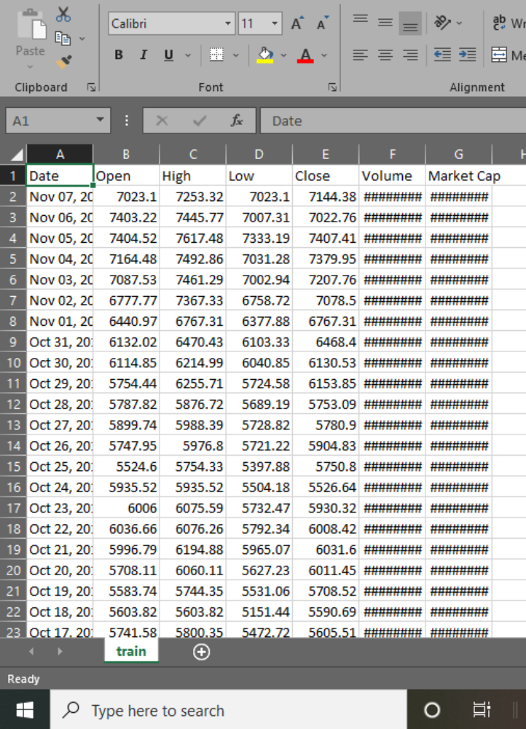
Fig.7.1 Data Collection
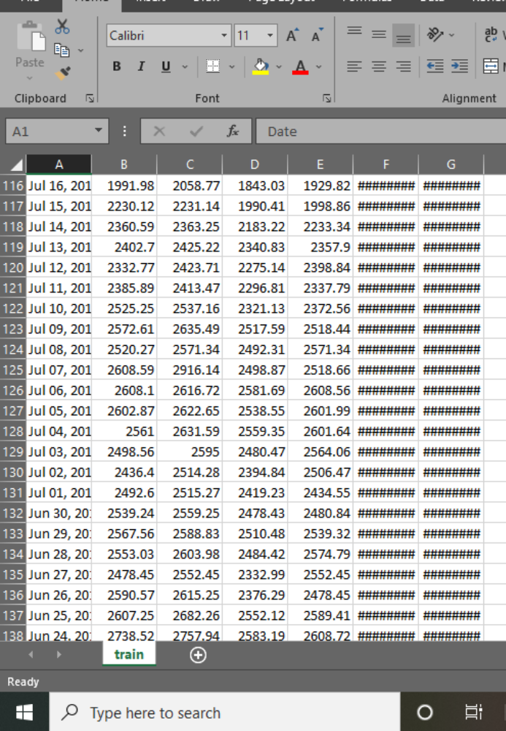
Fig.7.2 Data Collection
7.2 Data Quality Assessment
Data is often taken from multiple sources which are normally not too reliable and that too in different formats, more than half our time is consumed in dealing with data quality issues when working on a machine learning problem. It is simply unrealistic to expect that the data will be perfect. There may be problems due to human error, limitations of measuring devices, or flaws in the data collection process. Let’s go over a few of them and methods to deal with them:

- Missing Values
It is very much usual to have missing values in your dataset. It may have happened during data collection, or maybe due to some data validation rule, but regardless missing values must be taken into consideration. • Simple and sometimes effective strategy. Failsif many objects have missing values. If a feature has mostly missing values, then that feature itself can also be eliminated.
• If only a reasonable percentage of values are missing, then we can also run simple interpolation methods to fill in those values. However, most common method of dealing with missing values is by filling them in with the mean, median or mode value of the respective feature.
2.InconsistentValues
We know that data can contain inconsistent values. Most probably we have already faced this issue at some point. For instance, the ‘Address’ field contains the ‘Phone number’. It may be due to human error or maybe the information was misread while being scanned from a handwritten form. It is therefore always advised to perform data assessment like knowing what the data type of the features should be and whether it is the same for all the data objects.
3.Duplicate Values
A dataset may include data objects which are duplicates of one another. It may happen when say the same person submits a form more than once. The term deduplication is often used to refer to the process of dealing with duplicates. In most cases, the duplicates are removed so as to not give that particular data object an advantage or bias, when running machine learning algorithms.
4.Feature Aggregation
Feature Aggregations are performed so as to take the aggregated values in order to put the data in a better perspective. Think of transactional data, suppose we have day-to-day transactions of a product from recording the daily sales of that product in various store locations over the year. Aggregating the transactions to single store-wide monthly or yearly transactions will help us reducing hundreds or potentially thousands of transactions that occur daily at a specific store, thereby reducing the number of data objects
. • This results in reduction of memory consumption and processing time
• Aggregations provide us with a high-level view of the data as the behaviour of groups or aggregates is more stable than individual data objects
5.Feature Sampling
Using a sampling algorithm can help us reduce the size of the dataset to a point where we can use a better, but more expensive, machine learning algorithm. The key principle here is that the sampling should be done in such a manner that the sample generated should have approximately the same properties as the original dataset, meaning that the sample is representative. This involves choosing the correct sample size and sampling. Simple Random Sampling dictates that there is an equal probability of selecting any particular entity. It has two main variations as well:
• Sampling without Replacement:
As each item is selected, it is removed from the set of all the objects that form the total dataset.
• Sampling with Replacement:
Items are not removed from the total dataset after getting selected. This means they can get selected more than once.
CHAPTER 8
IMPLEMENTATION AND RESULT ANALYSIS
8.1 Introduction
Some statistical tests can be carried out on the close price of financial instruments (to ascertain key metrics which can further be used to better understand market behavior); one of which is the Augmented Dickey-Fuller test. This test is used to check if a particular asset or instrument will revert to its rolling mean after a market swing (in upwards or downwards direction).
The Bitcoin stock-to-flow model makes it possible to trade it against a base currency on the foreign exchange market. This means that as with the Volatility 10 index above, bitcoin can be represented (on the charts) by its open, high, low and close prices and consequently traded with leverage at varying trade volumes.
8.2 Implementation
LSTM (Long Short-Term Memory) is a deep learning model that helps with prediction of sequential data. LSTM models prevail significantly where there is a need to make predictions on a sequence of data. The daily OHLC (Open, High, Low and Close) price of any financial asset constitutes a good example of a sequential data. LSTMs are an extension of the classic recurrent networks, which address the (the gradient tends to zero as the error propagates through many layers recursively). The long-short term memory cell uses an input, a forget and an output gate. Those gates help the network learns what to save, what to forget, what to remember, what to pay attention and what to output. Pretty neat right? Remember that a gate is nothing more than a simple multilayer perceptron, but a smart combination of them can provide amazing results.
Each LSTM cell has its cell state (c) and has the ability to add or remove information to it. The forget gate decides what to remove from the cell state(f), while the input gate (i) decides which values it will update

8.3 Source Code.
from keras.models import Sequential
from keras.layers import LSTM
from keras.layers import Dense import matplotlib. pyplot as plt
from sklearn.preprocessing import MinMaxScaler
from sklearn.metrics import mean_squared_error
from keras.layers import Activation, Dense, Dropout
from keras import optimizers
from pandas import Series
import pandas as pd
import NumPy
data = pd. read_csv (r'C:\Users\rachu\Downloads\Bitcoin (1)\Bitcoin\BTC-USD.csv')
data = data.set_index(pd.DatetimeIndex(data['Date']))['Close']
def difference (dataset, interval = 1):
diffList = list ()
for i in range (interval, len(dataset)):
num = dataset[i] - dataset[i - interval]
diffList.append(num)
backView = 3
def create dataset (dataset, backView = 1):
dataX, dataY = [], []
for i in range(len(dataset) - backView - 1):
a = dataset[i:(i + backView), 0]
dataX.append(a)
dataY.append(dataset[i + backView, 0])
return numpy.array(dataX), numpy.array(dataY)
# fix random seed for reproducibility
numpy.random.seed(0)
# loading dataset
dataframe = data
dataset = dataframe.values
dataset = dataset.astype('float64').reshape(-1, 1)
# Normalizing dataset
scaler = MinMaxScaler ()
dataset = scaler.fit_transform(dataset)
# split into train and test sets
train_size = int(len(dataset) * 0.67)
test_size = len(dataset) - train_size
train, test = dataset [0: train_size:], dataset [train_size: len(dataset),:]
# reshape into Y = t + 1 and X = t
trainX, trainY = create_dataset (train, backView)
testX, testY = create_dataset (test, backView)
# reshape input to [samples, time steps, features]
trainX = numpy.reshape(trainX, (trainX.shape[0], 1, trainX.shape[1]))
testX = numpy.reshape(testX, (testX.shape[0], 1, testX.shape[1]))
# create and fit the LSTM network
model = Sequential ()
model.add(LSTM(256, return_sequences = True, input_shape = (1, backView)))
model.add(LSTM(256))
model.add (Dense (1))
model.compile(loss='mean_squared_error', optimizer='adam')
model.fit(trainX, trainY, epochs = 50, verbose = 1, shuffle = False, batch_size = 50)
# make predictions
trainPredict = model.predict(trainX)
testPredict = model.predict(testX)
# invert predictions
trainPredict = scaler.inverse_transform(trainPredict)
trainY = scaler.inverse_transform([trainY])
train, test = dataset [0: train_size:], dataset[train_size: len(dataset), :]
# reshape into Y = t + 1 and X = t
trainX, trainY = create_dataset (train, backView)
testX, testY = create_dataset (test, backView)
# reshape input to [samples, time steps, features]
trainX = numpy. reshape(trainX, (trainX.shape[0], 1, trainX.shape[1]))
testX = numpy.reshape(testX, (testX.shape[0], 1, testX.shape[1]))
# create and fit the LSTM network
model = Sequential()
model.add (LSTM (256, return_sequences = True, input_shape = (1, backView)))
model.add (LSTM (256))
model.add(Dense (1)) model.compile(loss='mean_squared_error', optimizer='adam')
model.fit(trainX, trainY, epochs = 50, verbose = 1, shuffle = False, batch_size = 50)
# make predictions
trainPredict = model.predict(trainX)
testPredict = model.predict(testX)
# invert predictions
trainPredict = scaler.inverse_transform(trainPredict)
trainY = scaler.inverse_transform([trainY])
testPredictPlot[:, :] = numpy.nan
testPredictPlot[len(trainPredict) + (backView * 2) + 1:len(dataset) - 1,:] = testPredict
# plot baseline and predictions
plt. plot(scaler.inverse_transform(dataset), label = 'Actual')
plt.plot(trainPredictPlot, label = 'Training')
plt.plot(testPredictPlot, label = 'Testing')

plt.legend()

from datetime import datetime

import pandas as pd

import requests

def convertTimeStampToUTC(data):

return datetime.fromtimestamp(data)

def get URL (apiKey, cryptoSymbol, frequency, timestamp, maxRecords):

API_KEY = '&api_key=' + str(apiKey)

limit = '&limit=' + str(maxRecords)

header = 'fsym=' + str(cryptoSymbol)

currency = '&tsym=USD'

if (timestamp == ""):

URL = 'https://min-api.cryptocompare.com/data/v2/histo' + frequency + '?' + header

else:

URL = 'https://min-api.cryptocompare.com/data/v2/histo' + frequency + '?' + header + '&toTs=' + str(timestamp)
return url + currency + API_KEY + limit

def getCryptoData(apiKey, crypto, frequency, numOfRequests, maxRecords):

numOfRequests = 5

data = pd.DataFrame()

nextTimeStamp = 0

for i in range(0, numOfRequests):

if (nextTimeStamp == 0):

url = getURL (apiKey, crypto, frequency, "", maxRecords)

else:

url = getURL (apiKey, crypto, frequency, nextTimeStamp, maxRecords)

response = requests.get(url).json()

partialData = pd.DataFrame(response.get('Data').get('Data'))

nextTimeStamp = partialData['time'].min-1
data = pd.concat([data, partialData])

data = data.sort_values (by = ['time'],ignore_index = True)

data['timeUTC'] = data['time'].apply(convertTimdata['timeUTC']

data = data. reset index (drop = True)

return data

API_KEY = ""

crypto = "BTC"

numOfRequests = 5

maxRecords = 200

frequency = "hour"

cryptoData = getCryptoData(API_KEY, crypto, frequency, numOfRequests, maxRecords)

cryptoData

API_KEY = ""

crypto = "BTC"

numOfRequests = 5

maxRecords = 200

frequency = "day"

cryptoData = getCryptoData(API_KEY, crypto, frequency, numOfRequests, maxRecords)

cryptoData

API_KEY = ""

crypto = "BTC"

numOfRequests = 5

maxRecords = 200

frequency = "minute"

cryptoData = getCryptoData(API_KEY, crypto, frequency, numOfRequests, maxRecords)

cryptoData

8.4 Output Screens

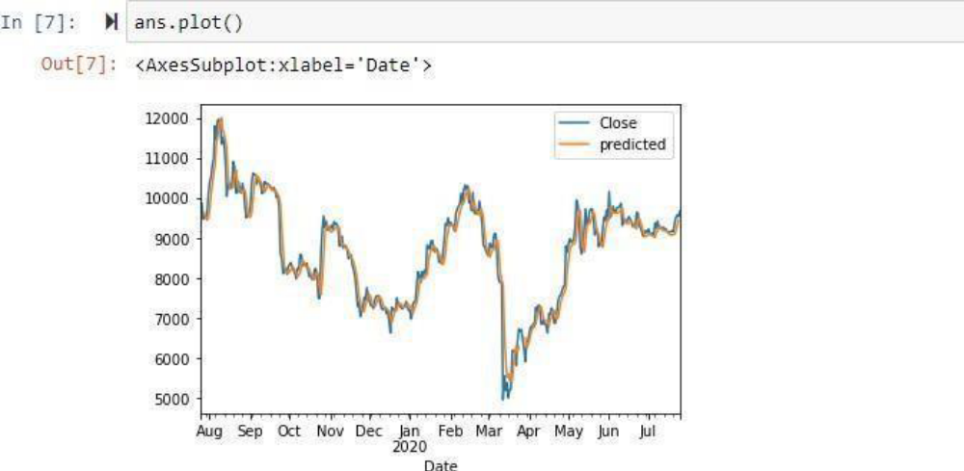
Fig.8.1: Graph of 2022
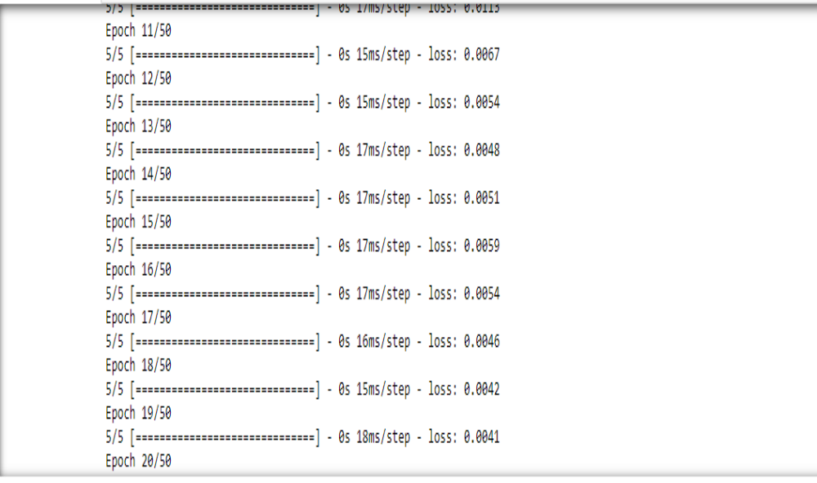
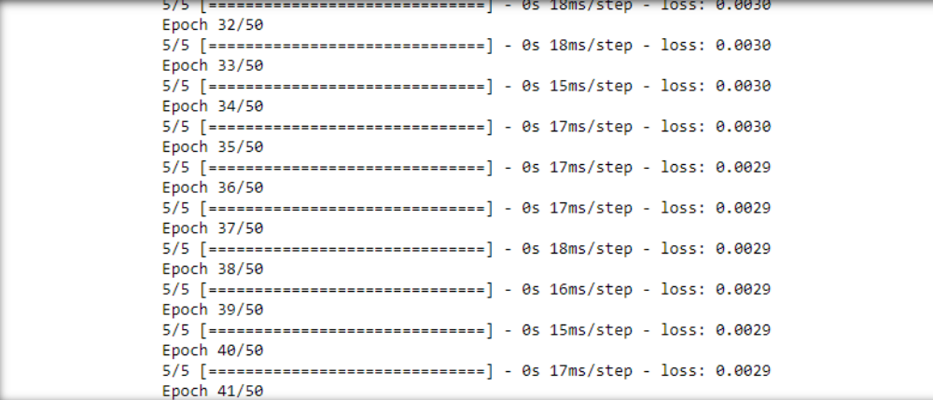
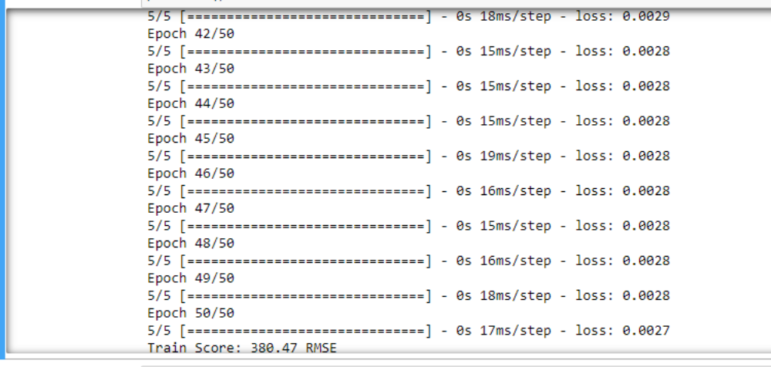
Fig.8.2 Epoch Graph
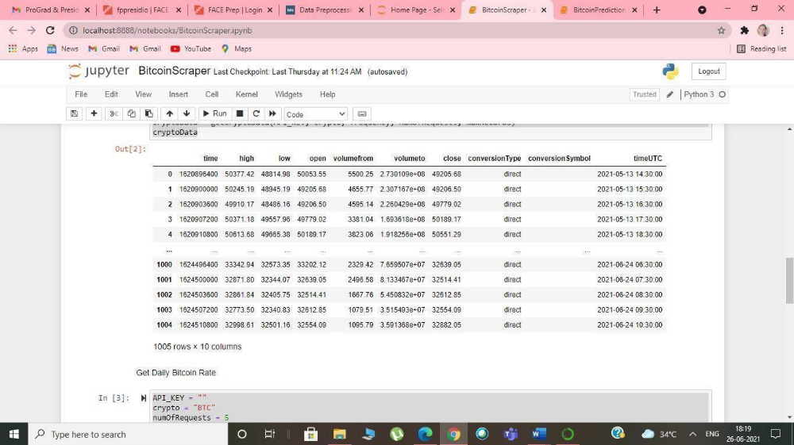
Fig 8.3 Daily Price Rate
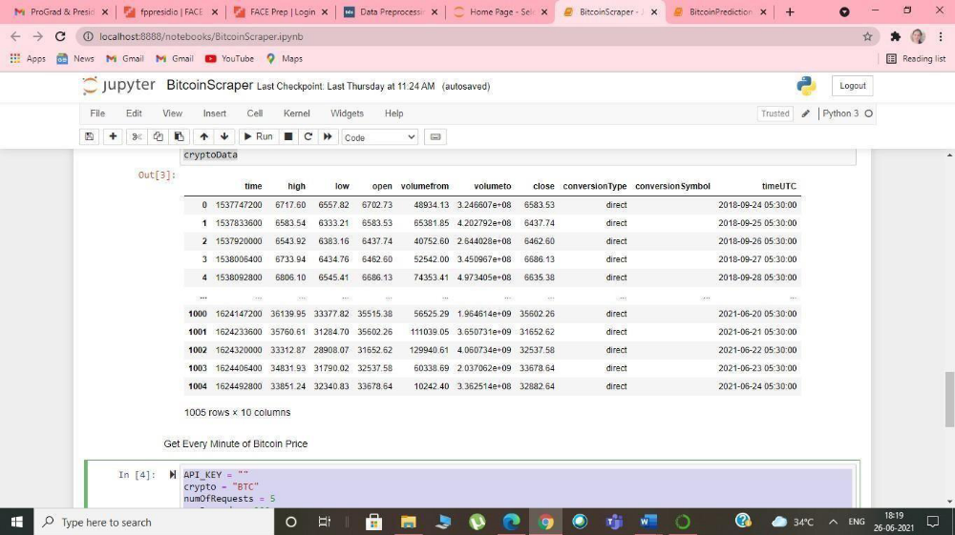
Fig 8.4 Minute Price Rate
Fig 8.5 Minute Price Rate

CHAPTER 9
TESTING AND VALIDATIOn
9.1. INTRODUCTION
The completion of a system is achieved only after it has been thoroughly tested. Though this gives a feel the project is completed, there cannot be any project without going through this stage. Hence in this stage it is decided whether the project can undergo the real time environment execution without any break downs, therefore a package can be rejected even at this stage. Testing is a set of activities that can be planned in advance and conducted systematically. The proposed system is tested in parallel with the software that consists of its own phases of analysis, implementation, testing and maintenance.
9.2 TESTING STRATEGIES

A Strategy for software testing integrates software test cases into a series of wellplanned steps that result in the successful construction of software. Software testing is a broader topic for what is referred to as Verification and Validation. Verification refers to the set of activities that ensure that the software correctly implements a specific function. Validation refers the set of activities that ensure that the software that has been built is traceable to customer’s requirements

• Unit Testing

Unit testing focuses verification effort on the smallest unit of software design that is the module. Using procedural design description as a guide, important control paths are tested to uncover errors within the boundaries of the module. The unit test is normally white box testing oriented and the step can be conducted in parallel for multiple modules.

• Integration Testing

Integration testing is a systematic technique for constructing the program structure, while conducting test to uncover errors associated with the interface. The objective is to take unit tested methods and build a program structure that has been dictated by design.
• Top-down Integration
Top-down integrations is an incremental approach for construction of program structure. Modules are integrated by moving downward through the control hierarchy beginning with the main control program. Modules subordinate to the main program are incorporated in the structure either in the breath-first or depth-first manner.

• Bottom-up Integration

This method as the name suggests, begins construction and testing with atomic modules i.e., modules at the lowest level. Because the modules are integrated in the bottomup manner the processing required for the modules subordinate to a given level is always available and the need for stubs is eliminated.

• Validation Testing

At the end of integration testing software is completely assembled as a package. Validation testing is the next stage, which can be defined as successful when the software functions in the manner reasonably expected by the customer. Reasonable expectations are those defined in the software requirements specifications. Information contained in those sections form a basis for validation testing approach.

• System Testing

System testing is actually a series of different tests whose primary purpose is to fully exercise the computer-based system. Although each test has a different purpose, all work to verify that all system elements have been properly integrated to perform allocated functions.
• Security Testing

Attempts to verify the protection mechanisms built into the system.

• Performance Testing

This method is designed to test runtime performance of software within the context of an integrated system.

CHAPTER 10

CONCLUSION & FUTURESCOPE

10.1 CONCLUSION

In this project we conclude that survey report will be just introducing modules of Bitcoin price prediction and machine algorithms. Hear the Comparison table of ML algorithm model accuracy which tells that the Linear regression model will have most accuracy then the other algorithms. In this project we conclude that the linear regression algorithm is more efficient then the other algorithms. By taking help from that linear regression algorithm, We can implement the LASSO also. The time complexity reduction in bit coin price prediction using LASSO algorithm is tested by referring all other algorithms and came to a conclusion that LASSO is the best among all. The machine learning algorithms will improve that feature idea of crypto currencies. That will improve the market price of globule investments. In this paper we proposed the new algorithm to find the feature price accuracy. That helps the customer increments and profits.

10.2 FUTURE ENHANCEMENT

With the help of real time data it can further be predicted for upcoming years. It can be′ predicted accurately with help of API key this project can be improvised.

